**WEB PROGRAMING LANGUAGES WEEKLY ACTIVITY 02**

**1.example 1, calculator example**

Here is the screen shot:

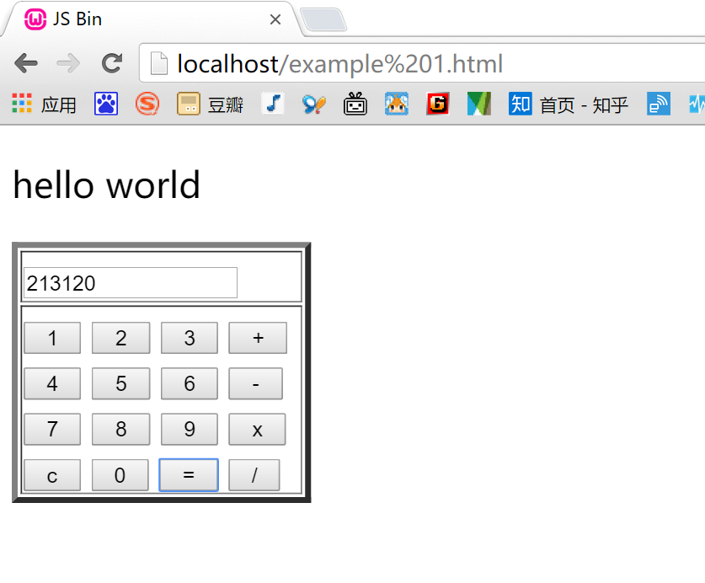

**Code:**

Please see attachment example 01.docx

**2.example 2, calendar**

**Screen shots**

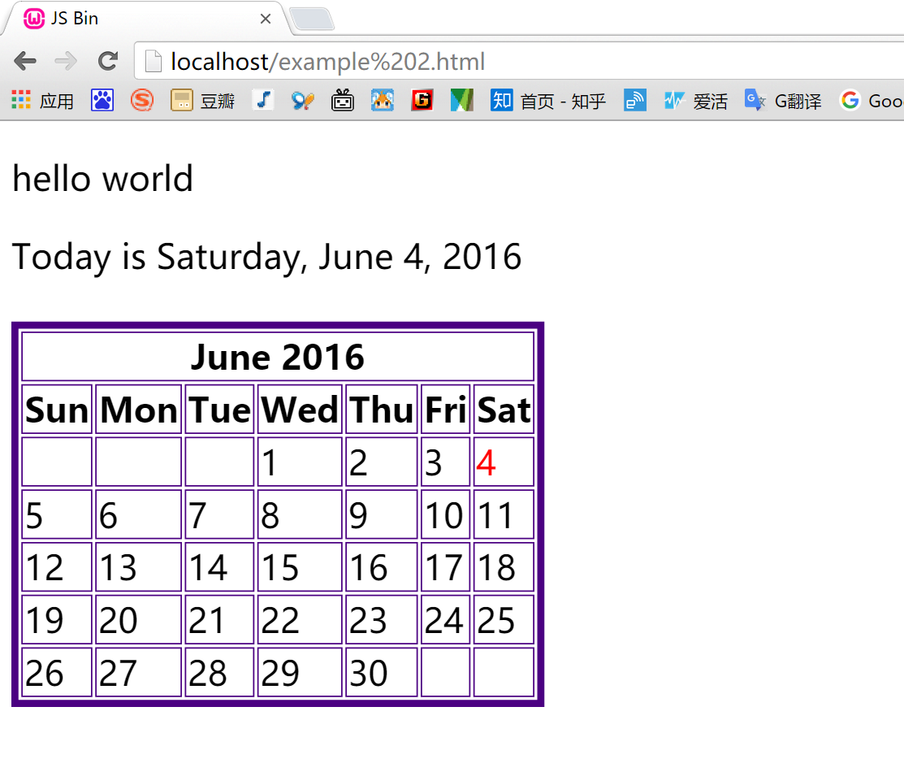

**Code:**

Please see attachment example 02.docx

**3.exapmle 3, jquery datepicke**

**Screen shot:**

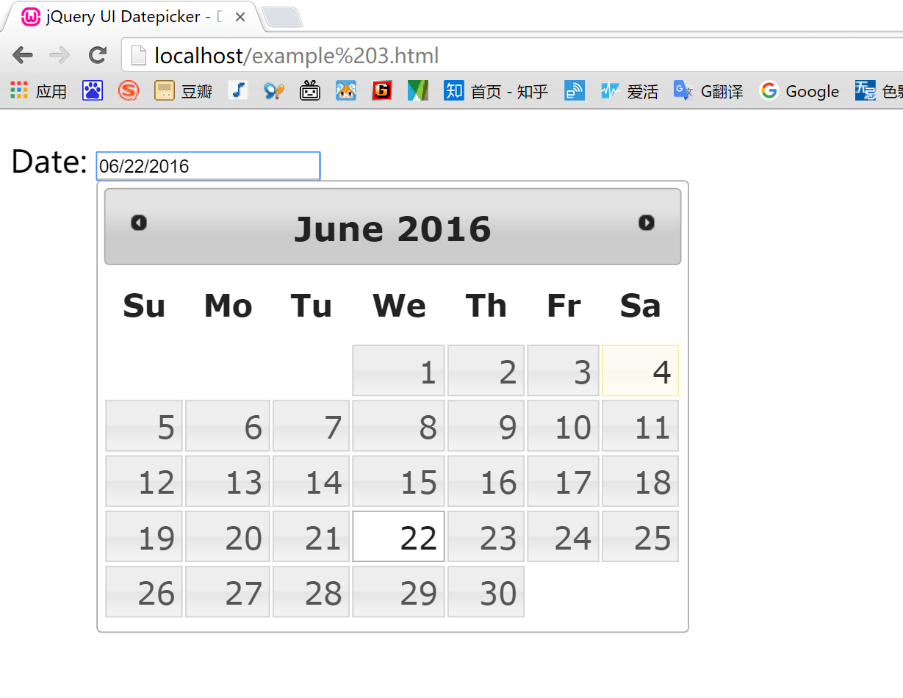

**Code:**

Please see attachment example 03.docx

1. **Example 4, datetimepicker**

**Screen shots:**

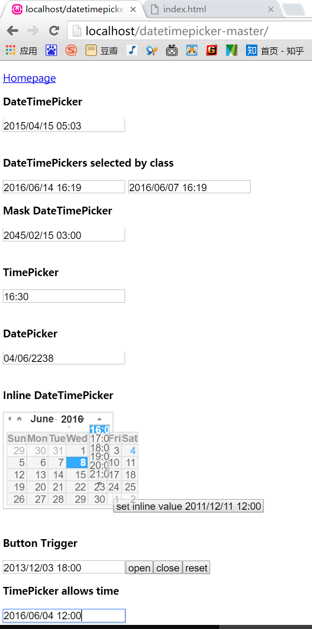

**Code (CSS & HTML):**

Please see attachment example 04.docx

|  |
| --- |
| **Table of Contents** |
| **Code example 1-4 screen shots.** |